[4.修改更新源sources.list，提高软件下载安装速度（提供Kali 2.0 更新源）](http://www.cnblogs.com/dunitian/p/4712852.html)

1.切换到root用户（如果已经是root用户就直接看第二步）

dnt@HackerKali:~$ **su**

密码：

2.用文本编辑器打开sources.list,手动添加下面的更新源

root@HackerKali:/home/dnt# **leafpad /etc/apt/sources.list**

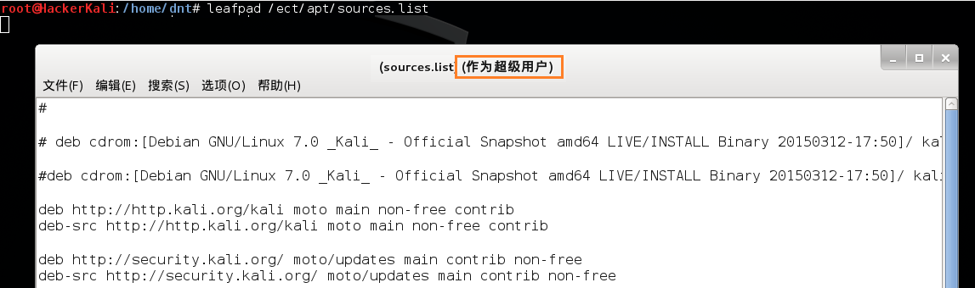

3.添加完毕后执行下面的更新指令，进行系统或者工具的更新

root@HackerKali:/home/dnt# **apt-get update && apt-get upgrade && apt-get dist-upgrade**

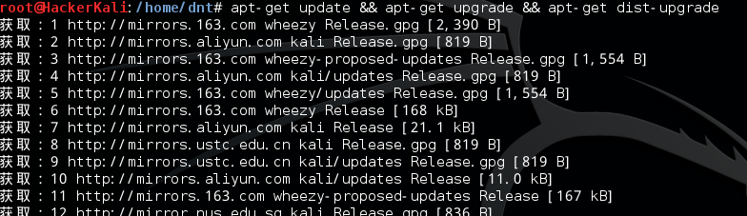

**---------------------------------Kali 2.0 ---更新源-----------------------------------**

[复制代码](javascript:void(0);)

**#科大的云**  
**deb http://mirrors.ustc.edu.cn/kali sana main non-free contrib**  
**deb-src http://mirrors.ustc.edu.cn/kali sana main non-free contrib**  
**deb http://mirrors.ustc.edu.cn/kali-security sana/updates main contrib non-free**

**#阿里云**  
**deb http://mirrors.aliyun.com/kali sana main non-free contrib**  
**deb-src http://mirrors.aliyun.com/kali sana main non-free contrib**  
**deb http://mirrors.aliyun.com/kali-security sana/updates main contrib non-free**

[复制代码](javascript:void(0);)

**----------------------------------Kali 1.0--更新源-------------------------------------**

[复制代码](javascript:void(0);)

#官方源

deb http://http.kali.org/kali kali main non-free contrib

deb-src http://http.kali.org/kali kali main non-free contrib

deb http://security.kali.org/kali-security kali/updates main contrib non-free

#中科大kali源

deb http://mirrors.ustc.edu.cn/kali kali main non-free contrib

deb-src http://mirrors.ustc.edu.cn/kali kali main non-free contrib

deb http://mirrors.ustc.edu.cn/kali-security kali/updates main contrib non-free

#新加坡kali源

deb http://mirror.nus.edu.sg/kali/kali/ kali main non-free contrib

deb-src http://mirror.nus.edu.sg/kali/kali/ kali main non-free contrib

deb http://security.kali.org/kali-security kali/updates main contrib non-free

deb http://mirror.nus.edu.sg/kali/kali-security kali/updates main contrib non-free

deb-src http://mirror.nus.edu.sg/kali/kali-security kali/updates main contrib non-free

#阿里云kali源

deb http://mirrors.aliyun.com/kali kali main non-free contrib

deb-src http://mirrors.aliyun.com/kali kali main non-free contrib

deb http://mirrors.aliyun.com/kali-security kali/updates main contrib non-free

#163 Kali源

deb http://mirrors.163.com/debian wheezy main non-free contrib

deb-src http://mirrors.163.com/debian wheezy main non-free contrib

deb http://mirrors.163.com/debian wheezy-proposed-updates main non-free contrib

deb-src http://mirrors.163.com/debian wheezy-proposed-updates main non-free contrib

deb-src http://mirrors.163.com/debian-security wheezy/updates main non-free contrib

deb http://mirrors.163.com/debian-security wheezy/updates main non-free contrib

#上海交大 Kali源 (比较慢，直接忽略)

#deb http://ftp.sjtu.edu.cn/debian wheezy main non-free contrib

#deb-src http://ftp.sjtu.edu.cn/debian wheezy main non-free contrib

#deb http://ftp.sjtu.edu.cn/debian wheezy-proposed-updates main non-free contrib

#deb-src http://ftp.sjtu.edu.cn/debian wheezy-proposed-updates main non-free contrib

#deb http://ftp.sjtu.edu.cn/debian-security wheezy/updates main non-free contrib

#deb-src http://ftp.sjtu.edu.cn/debian-security wheezy/updates main non-free contrib

[复制代码](javascript:void(0);)

-------------------------------------这个是我的sources.list(64位kali)----------------------------------------

[复制代码](javascript:void(0);)

#

# deb cdrom:[Debian GNU/Linux 7.0 _Kali_ - Official Snapshot amd64 LIVE/INSTALL Binary 20150312-17:50]/ kali contrib main non-free

#deb cdrom:[Debian GNU/Linux 7.0 _Kali_ - Official Snapshot amd64 LIVE/INSTALL Binary 20150312-17:50]/ kali contrib main non-free

deb http://http.kali.org/kali moto main non-free contrib

deb-src http://http.kali.org/kali moto main non-free contrib

deb http://security.kali.org/ moto/updates main contrib non-free

deb-src http://security.kali.org/ moto/updates main contrib non-free

#中科大kali源

deb http://mirrors.ustc.edu.cn/kali kali main non-free contrib

deb-src http://mirrors.ustc.edu.cn/kali kali main non-free contrib

deb http://mirrors.ustc.edu.cn/kali-security kali/updates main contrib non-free

#新加坡kali源

deb http://mirror.nus.edu.sg/kali/kali/ kali main non-free contrib

deb-src http://mirror.nus.edu.sg/kali/kali/ kali main non-free contrib

deb http://security.kali.org/kali-security kali/updates main contrib non-free

deb http://mirror.nus.edu.sg/kali/kali-security kali/updates main contrib non-free

deb-src http://mirror.nus.edu.sg/kali/kali-security kali/updates main contrib non-free

#阿里云kali源

deb http://mirrors.aliyun.com/kali kali main non-free contrib

deb-src http://mirrors.aliyun.com/kali kali main non-free contrib

deb http://mirrors.aliyun.com/kali-security kali/updates main contrib non-free

#163 Kali源

deb http://mirrors.163.com/debian wheezy main non-free contrib

deb-src http://mirrors.163.com/debian wheezy main non-free contrib

deb http://mirrors.163.com/debian wheezy-proposed-updates main non-free contrib

deb-src http://mirrors.163.com/debian wheezy-proposed-updates main non-free contrib

deb-src http://mirrors.163.com/debian-security wheezy/updates main non-free contrib

deb http://mirrors.163.com/debian-security wheezy/updates main non-free contrib

[复制代码](javascript:void(0);)

如果出现下面这种情况，说明权限不够，请切换到root权限

